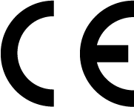
Medical Devices Directive 93/42/EEC
Comply with the Requirements of the MDD

The Medical Devices Directive 93/42/EEC defines safety and reliability requirements for medical equipment to be sold in the EEC. The requirements apply to both products and manufacturers. ​ The Medical Devices Directive (MDD) applies to all general medical devices not covered by the Active Implantable Medical Devices Directive or the In Vitro Diagnostics Directive. In order to be compliant with MDD, you need to classify your products correctly. The MDD divides products into different classes, based on risk and intended use, which again determines the relevant conformity assessment procedure. For products classified with medium to high degree of risk, the MDD requires a conformity assessment procedure involving a notified body.
notified body Can do for all medical devices under the quality modules of the Medical Devices Directive, annexes II, V and VI. We are able to assess and certify your quality system so that you can affix the CE mark to your products according to MDD. The CE mark is a requirement to be able to sell medical products and equipment in the EU. Additionally, an increasing number of other markets require CE marking. We carry out the CE assessments at customers’ premises. We can also provide guidance and interpretation of the directive related to your products in particular, and provide training for better understanding of the directive.

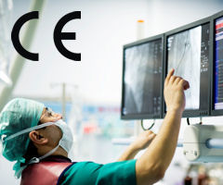
Before you can market your medical device in the EU, your product must meet the essential requirements in Annex 1 of the Medical Devices Directive (MDD), as well as the standards related to your device class. With the support of our experienced team of testing experts, your path to compliance is clear; we offer guidance for creating your Technical File, documenting risk, establishing conformity to ISO 13485, and testing and certification to harmonized standards so that you can apply the CE Mark and get to market faster.
Reference the classification rules in Annex IX of the MDD to determine your device class:
• Class I devices with low risk such as external patient support products
• Class IIa/b devices with medium risk such as electro-medical devices
• Class III devices with high risk such as cardiovascular catheters

All Class IIa, IIb, and Class III devices require Notified Body approval

- IEC 60601-1 3rd Edition Standard
Design Reviews, Risk Assessment and Third-Party Approval for Your Medical Device
Your new and existing medical devices must demonstrate compliance with the latest revision of IEC 60601-1. We are a Nationally Recognized Testing Laboratory (NRTL) approved by OHSA, providing testing, certification, and in-lab support to help you navigate the new requirements of the 3rd Edition and to support your safety claims throughout North America and Europe. From development all the way through the review of your Risk Management File, we offer the following solutions to help you reach your target markets.
• Risk Management Consulting
• Customized On-site & Off-site Training Seminars
• Risk Management Systems Certification & Auditing: ISO 14971
• Testing and Certification to 60601-1, 3rd Edition
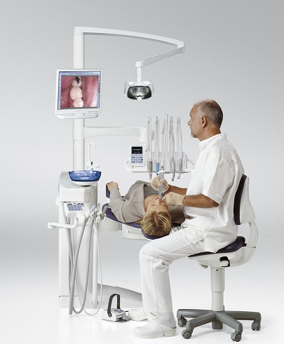

- EMC Testing for Medical Devices
IEC 60601-1-2:2007 Electromagnetic Compatibility (EMC) Testing
Wherever you are in your development cycle, we can provide EMC testing to meet your compliance needs. From product design to prototype evaluation and pre-compliance to full-compliance testing, our state-of-the-art 3-, 5-, and 10-meter EMC chambers are equipped to evaluate your medical device to requirements within the EMC Directive, including IEC 60601-1-2 and IEC 60601-2-x particular standards.
• Electro-static Discharge (ESD) Testing
• EMC Pre-compliance Scans
• Radiated Emissions Testing
• Radiated Immunity Testing

